* -: So requests are sent with the post method and we do only send them when we subscribe.
* Let's ignore the data we get back here for now, and let's now add another request that actually gets us all the posts.
* And for this I'll add a new private property in here which I'll name fetchPosts.
* And in here I want to again use the http client and now the get method

* and send a get request to that same URL we used for storing the data because that is the URL from which we'll be able to get that data.
* Now before we actually go further let's have a quick look at Firebase, and there you should now also see that post node here, and in there you have that cryptic key again which is an automatically generated ID by Firebase by the way, that's a convenience feature by Firebase.

* It generates such IDs for you.
* But if you expand this to you see your data.
* So now the goal is to fetch that data.
* We wanna fetch all the posts that were created.
* Therefore we're preparing this get request.
* And now since this is a get **request this also needs to know second argument** because get requests have no request body because while you're not sending any data, you are instead just requesting data.
* One thing you need to do here too, however is you need to subscribe.
* No subscription, no request.
* **So you need to subscribe here and we should get back our posts here.**
* That's the hope.

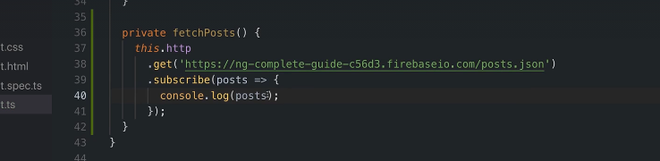

* So we get back our posts here and we can then console.
* log posts to get an idea of what we're actually getting back.

* Now I put this into that fetchPosts method because we can now call this from two different places from in onFetchPosts here right now just call this fetchPosts

* but I also want to call this from inside ngOnInit so whenever this page loads, whenever this app loads I want to fetch posts.
* and this show therefore call this method and send this request.
* Let's save this and this will reload the page and should now already send such a request.
* And indeed, here is some data we get back.
* And it looks like we're getting back a JavaScript object which has one key value pair in our case where the key is this cryptic key, this cryptic string and the value of that is the original object we stored so it's a nested object here that is the data we originally sent to the back and this is the data we are getting back.

* Now that of course, means that if I want to store all my posts in an array here for which we then can loop to output that we would need to transform this object here because it's a JavaScript object to an array and we need to transform that data while that screens for observable operators.